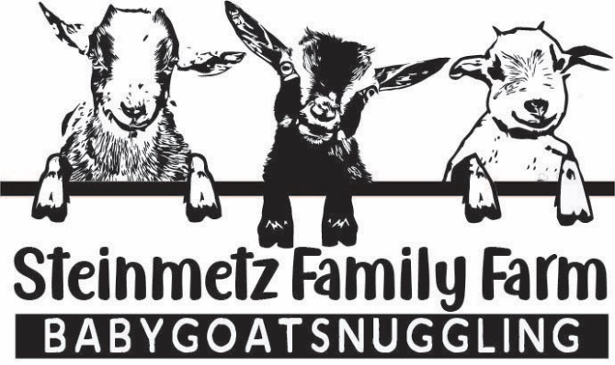
Thank you for your interest in our baby goats! At this time, we do not have any available for adoption. Feel free to fill out our WAITING LIST. We will have more available within the next few months.
Thanks! Justin & Lauren

